**DEPARTMENT OF COMPUTER SCIENCE**

**AKANU IBIAM FEDERAL POLYTECHNIC, UNWANA**

**P.M.B. 1007, AFIKPO. EBONYI STATE.**

**BASIC HARDWARE MAINTENANCE PRACTICAL ASSESSMENT BOOK**

Name :....................................................................................................

Reg. Num.:............................................................................................

Department :......................................................................................

Class :....................................................................................................

Date :.....................................................................................................

**In a world where fast evolving technologies are developed on minutely basis via computer and its related accessories, everybody needs to be interacting with information and communication technology (ICT) gadgets since almost everybody has computer systems or related computer accessories on his/her desk, laps or palms.**

**Acquiring computer systems are good, maintaining them are better but knowing and applying the maintenance skills are the best. The maintenance culture can still be cultivated from the knowledge of basic maintenance approach and there are two major types of maintenance which are:**

1. **Preventive Maintenance**
2. **Corrective Maintenance (Curative)**

**Although, there are many techniques available for maintaining a computer system but in this assessment book, students will be evaluated based on several practical they have carried out in the laboratory.**

**Exercise 1**

**Identify and label the diagram appropriately in the space provided below. State the function of each part.**

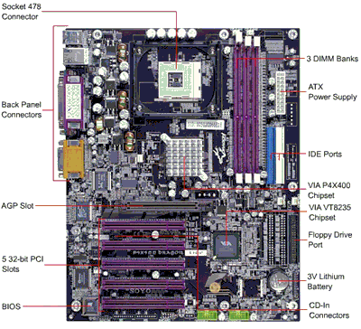

**.................................................................................................................................................**

**................................................................................................................................................**

**................................................................................................................................................**

**.................................................................................................................................................**

**................................................................................................................................................**

**................................................................................................................................................**

**.................................................................................................................................................**

**................................................................................................................................................**

**................................................................................................................................................**

**.................................................................................................................................................**

**................................................................................................................................................**

**................................................................................................................................................**

**.................................................................................................................................................**

**................................................................................................................................................**

**................................................................................................................................................**

**.................................................................................................................................................**

**................................................................................................................................................**

**................................................................................................................................................**

**.................................................................................................................................................**

**................................................................................................................................................**

**................................................................................................................................................**

**.................................................................................................................................................**

**................................................................................................................................................**

**................................................................................................................................................**

**.................................................................................................................................................**

**................................................................................................................................................**

**................................................................................................................................................**

**.................................................................................................................................................**

**................................................................................................................................................**

**................................................................................................................................................**

**.................................................................................................................................................**

**................................................................................................................................................**

**Exercise 2**

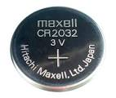**Identify and explain the function and the uses of the object below.**

**.................................................................................................................................................**

**................................................................................................................................................**

**................................................................................................................................................**

**.................................................................................................................................................**

**................................................................................................................................................**

**................................................................................................................................................**

**.................................................................................................................................................**

**................................................................................................................................................**

**................................................................................................................................................**

**.................................................................................................................................................**

**................................................................................................................................................**

**................................................................................................................................................**

**.................................................................................................................................................**

**................................................................................................................................................**

**................................................................................................................................................**

**.................................................................................................................................................**

**................................................................................................................................................**

**................................................................................................................................................**

**.................................................................................................................................................**

**................................................................................................................................................**

**Exercise 3**

**What is the name of the figure below? Explain what happens when a computer system is without or having a faulty one.**

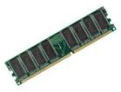

**.................................................................................................................................................**

**................................................................................................................................................**

**................................................................................................................................................**

**.................................................................................................................................................**

**................................................................................................................................................**

**................................................................................................................................................**

**.................................................................................................................................................**

**................................................................................................................................................**

**................................................................................................................................................**

**.................................................................................................................................................**

**................................................................................................................................................**

**................................................................................................................................................**

**.................................................................................................................................................**

**................................................................................................................................................**

**................................................................................................................................................**

**.................................................................................................................................................**

**................................................................................................................................................**

**Exercise 4**

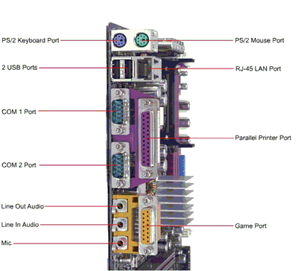**Which part of the computer system is the figure below? Label it appropriately.**

**................................................................................................................................................**

**.................................................................................................................................................**

**................................................................................................................................................**

**................................................................................................................................................**

**.................................................................................................................................................**

**................................................................................................................................................**

**................................................................................................................................................**

**.................................................................................................................................................**

**................................................................................................................................................**

**.................................................................................................................................................**

**Exercise 5**

**Identify and state the function of the device below.**

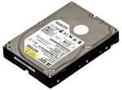

**................................................................................................................................................**

**................................................................................................................................................**

**.................................................................................................................................................**

**................................................................................................................................................**

**................................................................................................................................................**

**.................................................................................................................................................**

**................................................................................................................................................**

**.................................................................................................................................................**

**................................................................................................................................................**

**................................................................................................................................................**

**................................................................................................................................................**

**.................................................................................................................................................**

**................................................................................................................................................**

**................................................................................................................................................**

**.................................................................................................................................................**

**Exercise 6**

**Differentiate the two devices below and state the limitations of each of them.**

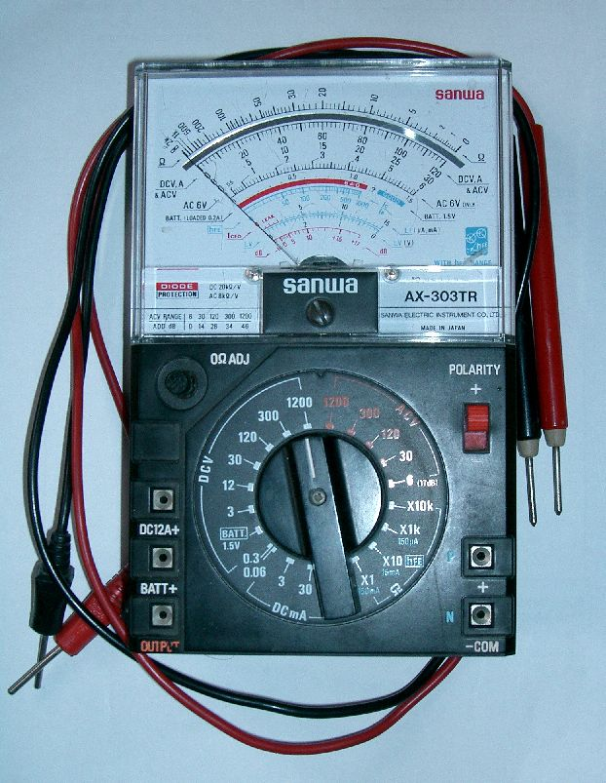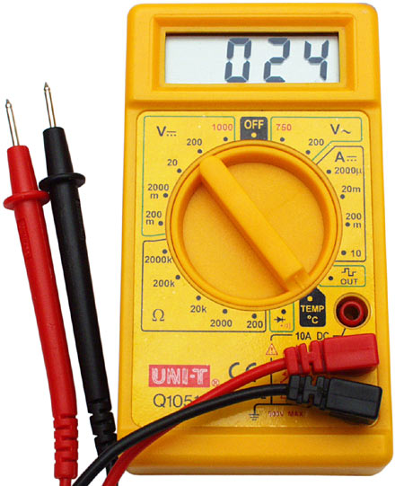

**................................................................................................................................................**

**................................................................................................................................................**

**.................................................................................................................................................**

**................................................................................................................................................**

**................................................................................................................................................**

**.................................................................................................................................................**

**................................................................................................................................................**

**.................................................................................................................................................**

**................................................................................................................................................**

**................................................................................................................................................**

**................................................................................................................................................**

**.................................................................................................................................................**

**................................................................................................................................................**

**................................................................................................................................................**

**.................................................................................................................................................**

**................................................................................................................................................**

**.................................................................................................................................................**

**................................................................................................................................................**

**................................................................................................................................................**

**................................................................................................................................................**

**.................................................................................................................................................**

**................................................................................................................................................**

**................................................................................................................................................**

**.................................................................................................................................................**

**................................................................................................................................................**

**.................................................................................................................................................**

**................................................................................................................................................**

**................................................................................................................................................**

**................................................................................................................................................**

**.................................................................................................................................................**

**................................................................................................................................................**

**................................................................................................................................................**

**.................................................................................................................................................**

**................................................................................................................................................**

**.................................................................................................................................................**

**................................................................................................................................................**

**................................................................................................................................................**

**................................................................................................................................................**

**.................................................................................................................................................**

**Exercise 7**

**Explain in details how a version of an operating system can be loaded into a new computer system.**

**................................................................................................................................................**

**................................................................................................................................................**

**.................................................................................................................................................**

**................................................................................................................................................**

**................................................................................................................................................**

**.................................................................................................................................................**

**................................................................................................................................................**

**.................................................................................................................................................**

**................................................................................................................................................**

**................................................................................................................................................**

**................................................................................................................................................**

**.................................................................................................................................................**

**................................................................................................................................................**

**................................................................................................................................................**

**.................................................................................................................................................**

**................................................................................................................................................**

**.................................................................................................................................................**

**................................................................................................................................................**

**................................................................................................................................................**

**................................................................................................................................................**

**.................................................................................................................................................**

**................................................................................................................................................**

**................................................................................................................................................**

**.................................................................................................................................................**

**................................................................................................................................................**

**.................................................................................................................................................**

**................................................................................................................................................**

**................................................................................................................................................**

**................................................................................................................................................**

**.................................................................................................................................................**

**................................................................................................................................................**

**................................................................................................................................................**

**.................................................................................................................................................**

**................................................................................................................................................**

**.................................................................................................................................................**

**................................................................................................................................................**

**................................................................................................................................................**

**................................................................................................................................................**

**.................................................................................................................................................**

**................................................................................................................................................**

**................................................................................................................................................**

**.................................................................................................................................................**

**................................................................................................................................................**

**.................................................................................................................................................**

**................................................................................................................................................**

**................................................................................................................................................**

**................................................................................................................................................**

**.................................................................................................................................................**

**................................................................................................................................................**

**Exercise 8**

**What are three (3) necessary precautions to be taken prior to working on a faulty computer system? List three (3) common computer system faults and their remedies.**

**................................................................................................................................................**

**................................................................................................................................................**

**.................................................................................................................................................**

**................................................................................................................................................**

**................................................................................................................................................**

**.................................................................................................................................................**

**................................................................................................................................................**

**.................................................................................................................................................**

**................................................................................................................................................**

**................................................................................................................................................**

**................................................................................................................................................**

**.................................................................................................................................................**

**................................................................................................................................................**

**................................................................................................................................................**

**.................................................................................................................................................**

**................................................................................................................................................**

**.................................................................................................................................................**

**................................................................................................................................................**

**................................................................................................................................................**

**................................................................................................................................................**

**.................................................................................................................................................**

**................................................................................................................................................**

**................................................................................................................................................**

**.................................................................................................................................................**

**................................................................................................................................................**

**.................................................................................................................................................**

**................................................................................................................................................**

**................................................................................................................................................**

**................................................................................................................................................**

**.................................................................................................................................................**

**................................................................................................................................................**

**................................................................................................................................................**

**.................................................................................................................................................**

**................................................................................................................................................**

**.................................................................................................................................................**

**................................................................................................................................................**

**................................................................................................................................................**

**................................................................................................................................................**

**.................................................................................................................................................**

**................................................................................................................................................**

**................................................................................................................................................**

**.................................................................................................................................................**

**................................................................................................................................................**

**.................................................................................................................................................**

**................................................................................................................................................**

**................................................................................................................................................**

**................................................................................................................................................**

**.................................................................................................................................................**

**................................................................................................................................................**

**Exercise 9**

**From the power supply unit of the computer system (i.e. power pack), there are several wires with different colors and each of them has specific task. With respect to the above statement, what are the functions of the following wires?**

**Black wire, yellow wire, red wire, blue wire, white wire, orange wire, green wire, and purple wire.**

**................................................................................................................................................**

**................................................................................................................................................**

**.................................................................................................................................................**

**................................................................................................................................................**

**................................................................................................................................................**

**.................................................................................................................................................**

**................................................................................................................................................**

**.................................................................................................................................................**

**................................................................................................................................................**

**................................................................................................................................................**

**................................................................................................................................................**

**.................................................................................................................................................**

**................................................................................................................................................**

**................................................................................................................................................**

**.................................................................................................................................................**

**................................................................................................................................................**

**.................................................................................................................................................**

**................................................................................................................................................**

**................................................................................................................................................**

**................................................................................................................................................**

**.................................................................................................................................................**

**................................................................................................................................................**

**................................................................................................................................................**

**.................................................................................................................................................**

**................................................................................................................................................**

**.................................................................................................................................................**

**................................................................................................................................................**

**................................................................................................................................................**

**................................................................................................................................................**

**.................................................................................................................................................**

**................................................................................................................................................**

**................................................................................................................................................**

**.................................................................................................................................................**

**................................................................................................................................................**

**.................................................................................................................................................**

**................................................................................................................................................**

**................................................................................................................................................**

**................................................................................................................................................**

**.................................................................................................................................................**

**................................................................................................................................................**

**................................................................................................................................................**

**.................................................................................................................................................**

**................................................................................................................................................**

**.................................................................................................................................................**

**................................................................................................................................................**

**................................................................................................................................................**

**................................................................................................................................................**

**Exercise 10**

**How can you make a computer system be in safe mode and what is the essence of safe mode?**

**................................................................................................................................................**

**................................................................................................................................................**

**.................................................................................................................................................**

**................................................................................................................................................**

**................................................................................................................................................**

**.................................................................................................................................................**

**................................................................................................................................................**

**.................................................................................................................................................**

**................................................................................................................................................**

**................................................................................................................................................**

**................................................................................................................................................**

**.................................................................................................................................................**

**................................................................................................................................................**

**................................................................................................................................................**

**.................................................................................................................................................**

**................................................................................................................................................**

**.................................................................................................................................................**

**................................................................................................................................................**

**................................................................................................................................................**

**................................................................................................................................................**

**.................................................................................................................................................**

**................................................................................................................................................**

**................................................................................................................................................**